Dashboard Design

Date | 19 September 2026
Team ID | MCA
Project Name | Smartphone Usage & Digital Addiction and Well-Being Analytics
Maximum Marks | 5 Marks

Designing an effective dashboard for Smartphone Usage, Digital Addiction and Well-Being Analytics requires presenting usage behavior, addiction indicators and lifestyle outcomes in a clear, interactive and user-friendly format. The dashboard supports analysis of daily screen time, app usage, sleep duration, stress level, physical activity and overall well-being.

Activity 1: Interactive and Visually Appealing Dashboard
The proposed dashboard combines KPI cards, charts, filters and summary indicators to provide a quick understanding of smartphone usage and digital well-being. It allows users to compare groups and explore patterns based on age, gender, occupation, addiction level and well-being category.
Clear and Intuitive Layout
Arrange KPI cards, charts, tables and filters in a logical order so users can easily understand the main results.
Use Appropriate Visualizations
Use bar charts for age-wise screen time, pie charts for addiction categories, line or scatter charts for usage and sleep relationships, and KPI cards for key measures.
Color and Theming
Use a consistent color scheme to distinguish low, moderate and high usage or addiction levels while keeping the dashboard readable.
Interactive Filters and Slicers
Include filters for age group, gender, occupation, daily screen time, app category, addiction level, sleep duration and well-being category.
Drill-Down Capabilities
Allow users to move from overall results to detailed views by age group, gender, occupation, addiction category or well-being level.
Responsive Design
Place charts, KPI cards, tables and slicers so that the dashboard remains clear and usable on different screen sizes.
Custom Visuals and Icons
Use simple icons for screen time, smartphone usage, sleep, stress, physical activity and mental well-being.
Use of Infographics
Use infographic-style KPI cards and visual indicators to communicate important results quickly and make the dashboard engaging.
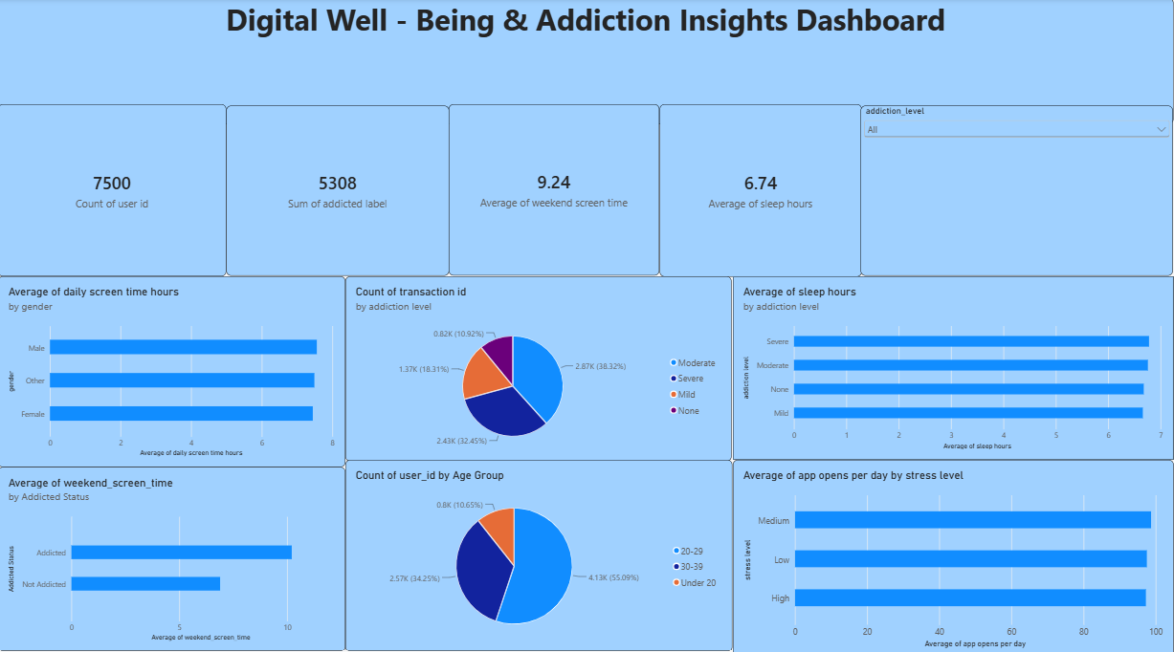

Note: Highlight the major outcomes in the form of bullet points
Sample:
Potential outcomes from the Smartphone Usage, Digital Addiction and Well-Being Analytics dashboard:
Major Outcomes from the Dashboard
- Total Users: Displays the total number of users included in the dataset.
- Average Daily Screen Time: Shows the average number of hours users spend on smartphones each day.
- Addiction Category Distribution: Classifies users into low, moderate and high digital addiction categories.
- Age-wise Usage Comparison: Compares smartphone usage across different age groups.
- Sleep and Screen Time Analysis: Examines the relationship between daily screen time and sleep duration.
- Stress and Addiction Analysis: Identifies patterns between digital addiction levels and reported stress.
- Physical Activity Comparison: Compares physical activity levels among users with different smartphone usage patterns.
Overall Well-Being Score: Summarizes well-being using screen time, sleep, stress and physical activity indicators.

